

Blue Hygiene Roll 40m 9 pack

Product Code: | BHR409 |  | 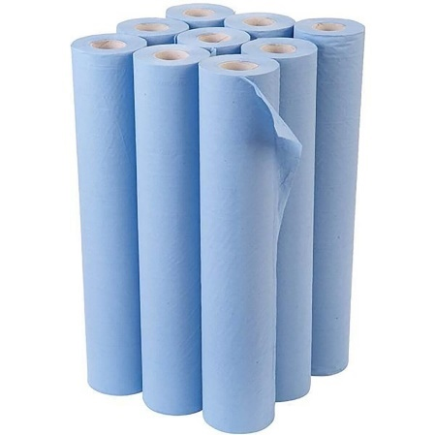
Date of issue: | 01/06/2023
Commodity Code: | 48030090
Country of Origin: | UK

Roll Specification |  |  | Pallet Specification
Paper Type: | Recycled |  | Cases per Layer: | 9
Colour: | Blue |  | Layer per Pallet: | 4
Ply: | 2ply |  | Pallet Height: | 2.1m
GSM Per Ply: | 17 |  | Cases per Pallet: | 36
Sheet Width: | 500mm |  | Double Stacked: | No
Roll Length: | 40m
Core Diameter: | 50mm
Barcode: | 7342839834825

Case Specification |  |  | Accreditations
Case Quantity: | 9
Case Weight: | 6.4kg |  | 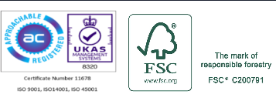  
Case Dimensions (WxLxH): | 340mm x 340mm x 510mm
Packaging Material: | LDPE Shrink contains a minimum 30% PCR |  | 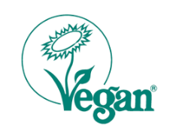  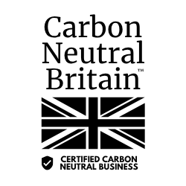
Packaging Disposal: | Recycled board core and LDPE wrap, both can be widely recycled.  

